

AMERICAN INTERNATIONAL UNIVERSITY-BANGLADESH

COMPUTER GRAPHICS – PROJECT DOCUMENTATION

|  |  |
| --- | --- |
| **Course Name** | Computer Graphics |
| **Section** | A |
| **Course Tutor** | Md. Masum Billah |
| **Project Title** | Artemis program |

**Group Members Information:**

|  |  |
| --- | --- |
| **Name** | **ID** |
| TIHAM MD. INKIAD | 20-43645-2 |
| DURJOY GHOSH | 20-43511-1 |
| YEASIR AHNAF ASIF | 20-42815-1 |
| SHORNALI AKTER | 20-42630-1 |

**Table of Content:**

|  |  |
| --- | --- |
| **Content List** | **Page No** |
| Introduction | 04 |
| Proposal | 03 |
| Schematic Diagram | 04 |
| List of Objects | 04-06 |
| Functions to Represent the Objects | 06 - 08 |
| Interactive Functions | 09 |
| Task Assignment and Codes of Functions | 10-11 |
| Output | 12-14 |
| Conclusion | 14 |

**Introduction**

The project will demonstrate a minimal look NASA's program to return astronauts to the lunar surface. We implemented a scenario of three view which are rocket launch, rocket in outer space and rocket land on moon; there will be day night features in all the views by the button press. There will sound effect of each difference scene. All together it would render a scenario of the NASA’s Artemis program. Our program provides fast and accurate rendering of the objects. as well as a landscape to simulate the views.

**Proposal**

The project about a scenario type. There will be a real-life scenario about “NASA's Artemis program”. There will be mountain, rockets, lunch platforms, earth from outer space, night stars, moon. There will be some keyboard connection which will be created. In the scenario there will be lunch and landing views start using keyboard.

**Schematic Diagram**

**Scenario 1**

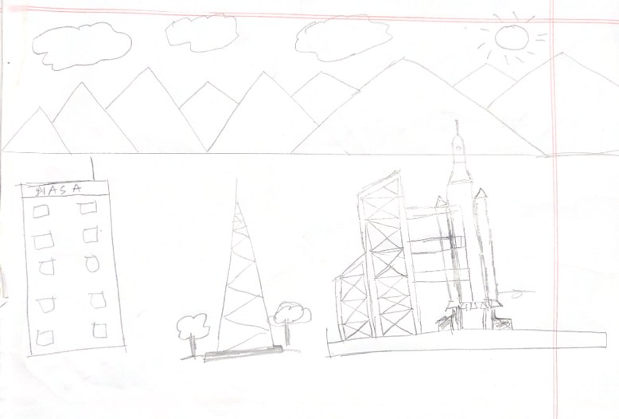

**Scenario 2**

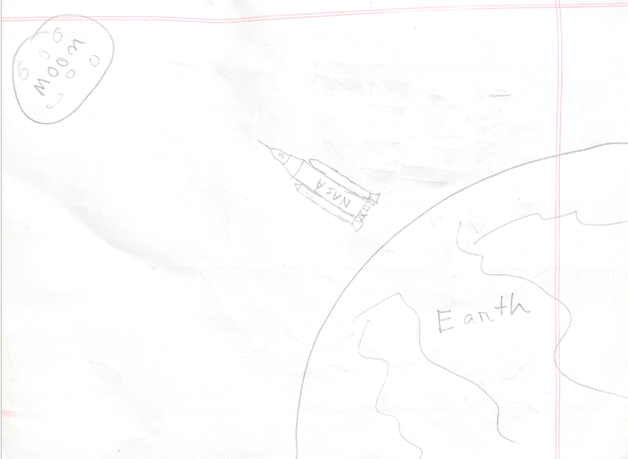

**List of Object**

1. Rocket
2. Sun
3. Tower
4. Moon
5. Cloud
6. Tree
7. Lunch pad
8. Smoke
9. Nasa building
10. Day sky
11. Night sky
12. Moon floor
13. Water
14. Earth
15. Earth mountain
16. Moon mountain
17. Astronaut
18. Night mountain
19. Moon base
20. Moon tree
21. Moon buildings

**Funtions to Represent The Objects**

|  |  |  |
| --- | --- | --- |
| **Object** | **Function** | **ID** |
| ship 1 | Void ship() | **1010** |
| Ship2 | Void ship_2 () | 1011 |
| Tower | Void tower() | 1012 |
| Rain | Void rain() | 1013 |
| Sun | Void sun() | 1014 |
| Moon | Void Moon() | 1015 |
| Cloud | Void Cloud() | 1016 |
| Bird | Void Bird() | 1017 |
| Tree | Void Tree() | 1018 |
| Umbrella | Void Umbrella() | 1019 |
| Seat | Void Seat() | 1020 |
| Balloon | Void Balloon() | 1021 |
| Day sky | Void Day_sky() | 1022 |
| Evening sky | Void Evening_sky() | 1023 |
| Stars | Void stars() | 1025 |
| Night sky | Void Night_sky() | 1026 |
| Sea Texture | Void Sea_Texture() | 1027 |
| Day Sea | Void Day_Sea() | 1041 |
| Evening sea | Void Evening_Sea() | 1028 |
| Night sea | Void Night_Sea() | 1029 |
| Sea wave | Void Sea_Wave() | 1030 |
| Day mountain | Void Day_Mountain() | 1031 |
| Evening mountain | Void Evening_Mountain() | 1032 |
| Night mountain | Void Night_Mountain() | 1033 |
| Mill | Void Mill() | 1034 |
| Day sand Texture | Void Day_sand_Texture() | 1035 |
| Evening sand Texture | Void Evening_sand_Texture() | 1036 |
| Night sand Texture | Void Night_sand_Texture() | 1037 |
| Day Sand | void Day_Sand() | 1038 |
| Night Sand | void Night_Sand() | 1039 |
| Evening sand | void Evening_Sand() | 1040 |

**Interactive Functions**

|  |  |  |
| --- | --- | --- |
| **Interactive Functions** | **Interaction** | **ID** |
| update_sun | sun_move, sun_update | 1001 |
| update_ship | sea_move, sea_update | **1002** |
| update_sea_wave | sea_move,sea_wave_update | 1003 |
| update_moon | moon_move, moon_update | 1004 |
| update_cloud | cloud_move, cloud_update | 1005 |
| update_balloon | balloon_move, balloon_update | 1006 |
| update_bird | bird_move, bird_update | 1007 |
| update_rain | rain_move, rain_update | 1008 |

**Task Assignment and Codes of Funchtions**

**Contribution Table:**

|  |  |  |  |  |
| --- | --- | --- | --- | --- |
| **Tiham Md. Inkiad** | **YEASIR AHNAF ASIF** | **DURJOY GHOSH** | **SHORNALI AKTER** | **TOTAL** |
| 25% | 25% | 25% | 25% | 100% |

|  |  |
| --- | --- |
| **Name**  **ID** | **Contribution in Project** |
| **Member-1** | 1. Day sky 2. Cloud 3. Sun 4. Mill 5. Baloon 6. Moon 7. Day sea |
| **Member-2** | 1. Ship1 2. Rain 3. Bird 4. Evening sky 5. Night sky 6. Sea texture 7. Sea wave 8. Day sand texture 9. Event Handler |
| **Member-3** | 1. Evening sea 2. Night sea 3. Day mountain 4. Evening mountain 5. Night mountain 6. Night sand 7. Evening sand 8. Night sand texture |
| **Member-4** | 1. Ship2 2. Seat 3. Umbrella 4. Stars 5. Tree 6. Tower 7. Day sand |

**OUTPUT**

|  |  |
| --- | --- |
| **Day View** |  |
| **Evening View** |  |
| **Night**  **view** |  |
| **Rain**  **view** |  |

**Conclusion**